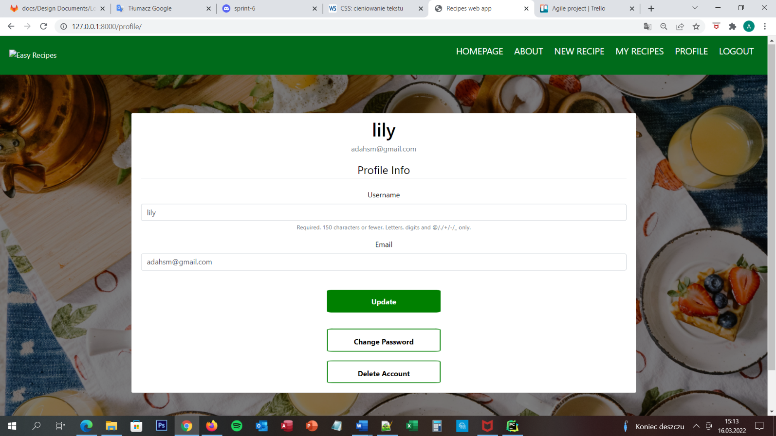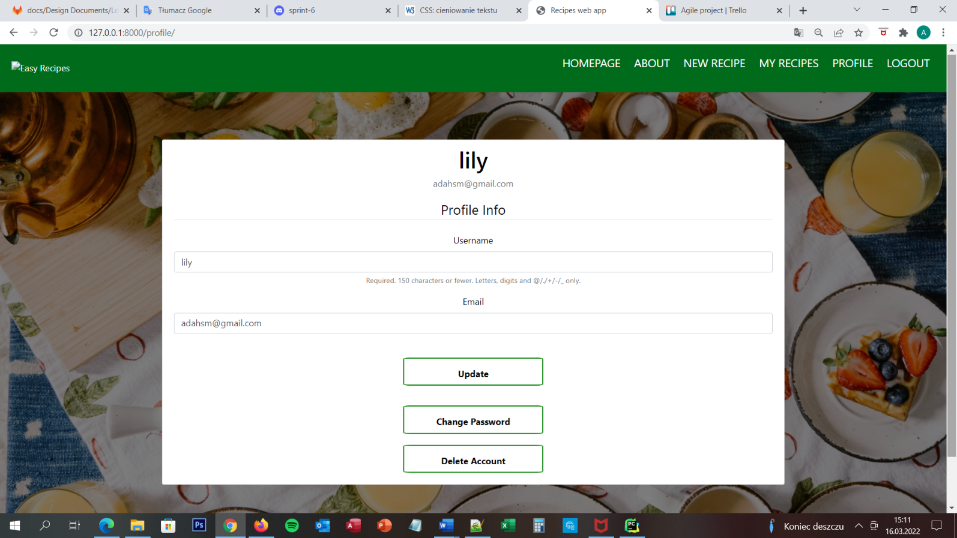Profile page Design document

## Profile page

When user successfully register in the website the server is creating profile for user. User needs to log in to the website and then he/she is able to click Profile button which is located on the navigation menu on the top of the screen. After he/she will press this button, user is move to the profile page. On this page user is able to see profile info like username and email address and he/she is able to update information about his/her account, change password or delete account. On the top of the screen he/she is able to see navigation menu with 6 buttons – HOMEPAGE, ABOUT, NEW RECIPES, MY RECIPES, PROFILE and LOGOUT. User is able to move to any of this pages by clicking the correct button on the navigation menu on the top of the screen.

## URL diagram

YES

YES

NO

NO

## User Story

User is able to see this website only when he/she is successfully log in to the page – he/she already has account on the website. On the profile page user is able to change the password, delete an account, add new recipe, display his/her recipes, display favourite recipes. The Profile Page is a page on which are display a lot of buttons for all of this functions.

All of the button are display on the centre of the screen and all of the buttons are legibly and clearly described to make sure that website is intuitive and clear for user.

## Acceptance Criteria

The page should display five buttons, profile information and navigation bar. Each button should be clearly named. Eight of nine buttons should move user to connecting pages:

* Change password to Change Password Page
* Delete account to Delete Account Page
* Homepage to homepage
* About to about page
* New recipes to Add recipe page
* My recipes to my recipes page
* Profile should reload the page
* Logout to logout page

Submit button should submit the information about profile and reload whole page. User is able to change username and email address and after he/she presses button SUBMIIT the new data is sending to the database and uploaded the User table.

## User interface – Pseudo code

The profile page is appear for the user when he/she is successfully log in to the website. This is the first page which he/she can see after log in. If user will go to recipe Page he/she can easily come back to the page by using the button – Profile – on the navigation bar. On the client side is to choose what user want to do and press the button or change the email address or username by delete and type something new and then press button Update. Server side looks like this:

* Display buttons
* Move user to specific webpage after he/she presses the button
* When user will change the username or email address the server side needs to check if all of this information are correct with requirements and then change them in the database